# QUALITY ASSURANCE TRAINING

**Website Analysis Report for Inhouse sister company of Innovative Investment Group (IIG)**

### 

| **Submitted By:** | **Submitted To:** |
| --- | --- |
| **Nischal Shrestha** | **Prajesh Shakya** |

### 

### **Date: 3rd March, 2025**

# 

# Quality Assurance Testing of IIG companies

## Introduction

* The following documentation contains an overview on Inhouse sister company websites of Innovative Investment Group. This documentation contains a thorough analysis on overall visual effects/changes needed on the different instances in general of those websites.

## 

## Contents

1. SR Logistics
2. Techart Trekkies
3. India International Group Nepal
4. Satyalaxmi Trading
5. Next Geekers
6. IT Switch Pvt. Ltd
7. Nepal Hygiene and Purity
8. Innovative Investment Group

## **SR Logistics**

* In the “Our Services” section, we can only view the services after pressing the “Learn more” button but the whole section turns blue when the user points their mouse to this part. So, it would be more user-friendly if the user can access information by pressing anywhere in these services sections as well.

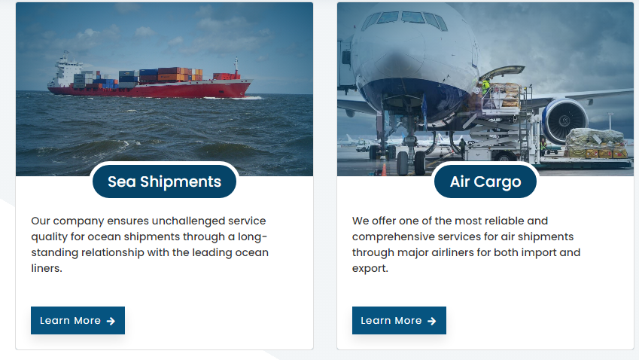

* In the Company Details section, the map location is there but it is not directing the user to the google maps.

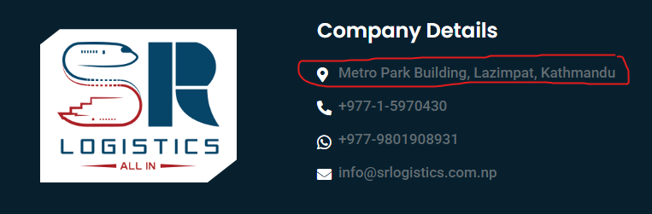

* When minimized the menu bar glitches out once in a while, sometimes it shows the cross sign and sometimes it shows the three line menu icon.

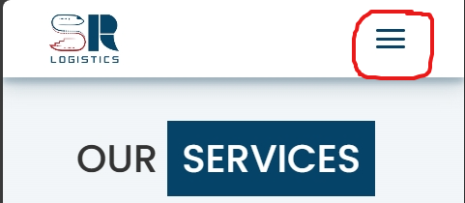



## **Techart Trekkies**

* This animation section looks very good on the webpage but once we minimize the web browser and see the animation, it overlaps with other parts of the webpage.

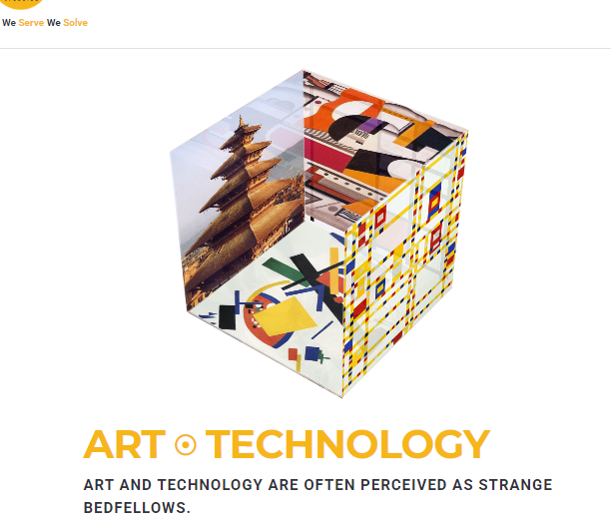

- In the portfolio section, the website “Nassar Overseas Pvt. Ltd Dynamic Website” is not active currently but there is still a link there which directs us to the Portfolio section of the Techart Trekkies website unlike other recent works.

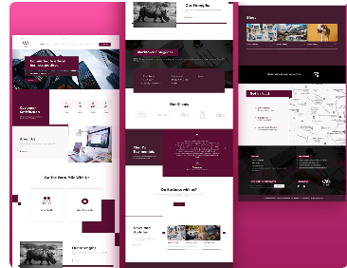

* When we view the recent works in the website’s portfolio section we can see a pop up box which includes the webpage layout of that website which is clean but the top section of that pop up box is still quite empty which can be used to keep the name of that same project. For example, “ABS Business Consultancy Pvt. Ltd Dynamic Website” text can be integrated on those empty spaces.

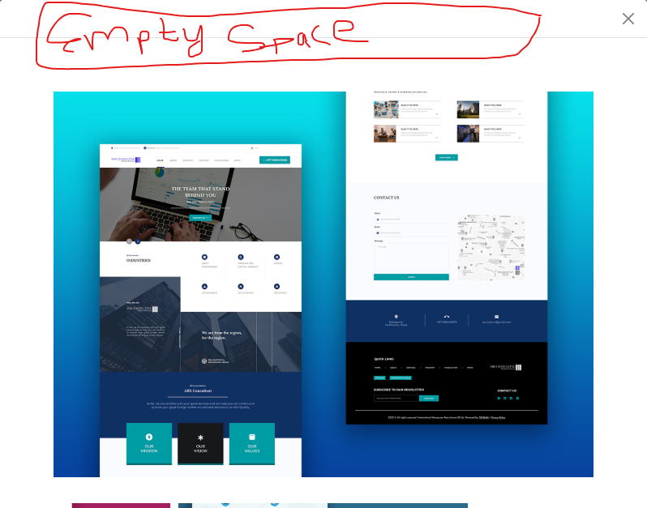

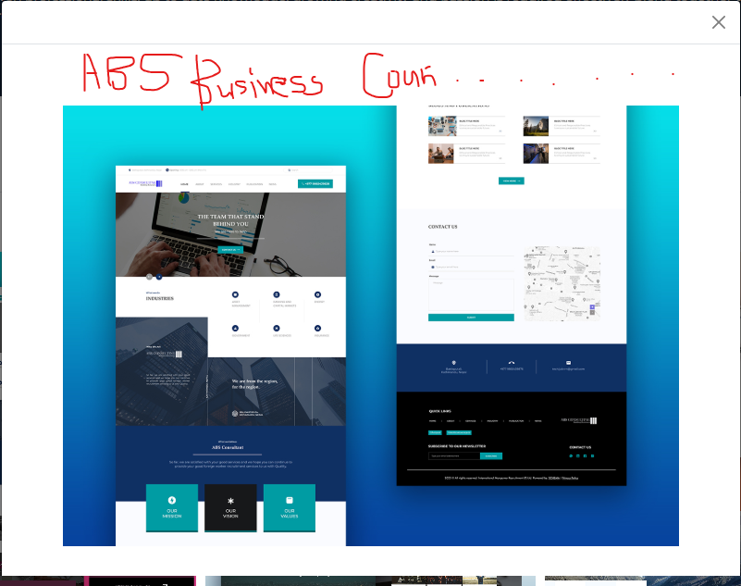

## **India International Group Nepal**

* The “Our Services” section is very eye appealing and clean to the user when the browser is in maximized mode.

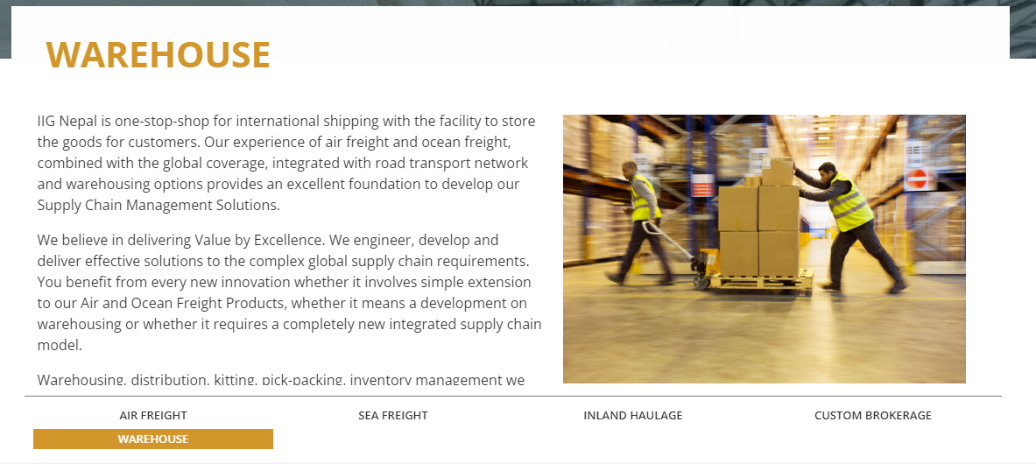

But once the browser is minimized the same section looks messy because that highlighted part does not align with the overall webpage.

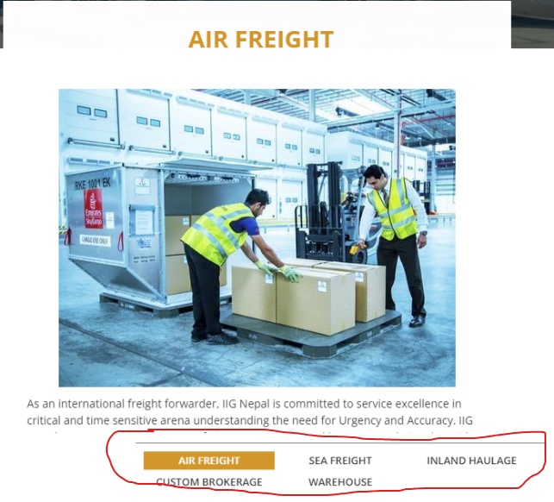

## **Satyalaxmi Trading**

* The landing page is very responsive but the nav link menus including Home, About etc. can be sorted in a hoverable dropdown menu for a smooth user experience.

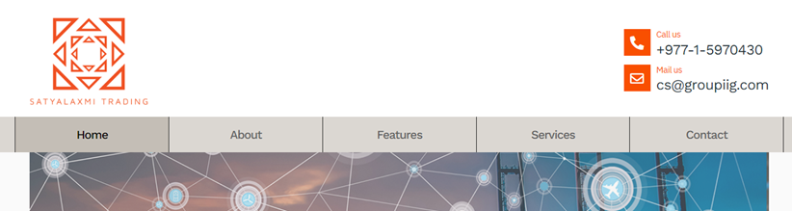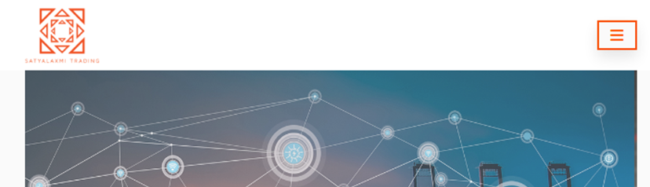

* The top section of the landing page has a lot of white space which can be integrated with the nav bar for more robust and user friendly design. (P.S.- It can get congested if not done properly though)

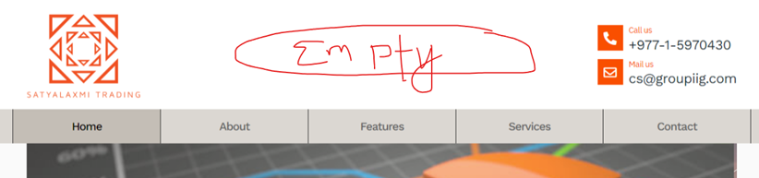

* The close button of the “Our Services” section is not aligned with the webpage format; it is overlapping the browser itself which makes the overall look a bit messy from the user perspective.

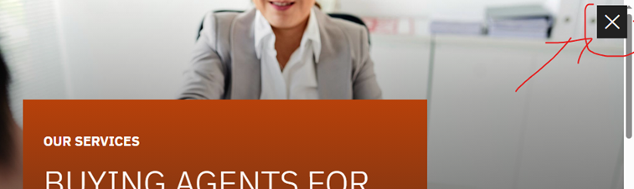

## **Next Geekers**

* This section overlapping the other parts of the webpage looks very disturbing and can be integrated with a more user friendly approach.



* The Login page is not linked in the Bills & Payment section of the webpage.

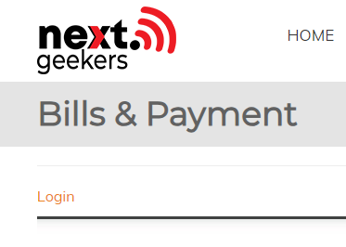

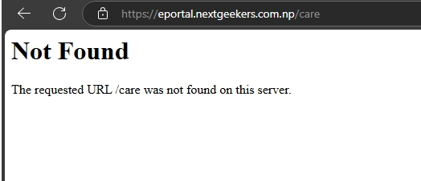

## **IT Switch Pvt. Ltd**

* Both of these *“read more”* sections are not linked in “Our Services” part of the webpage.

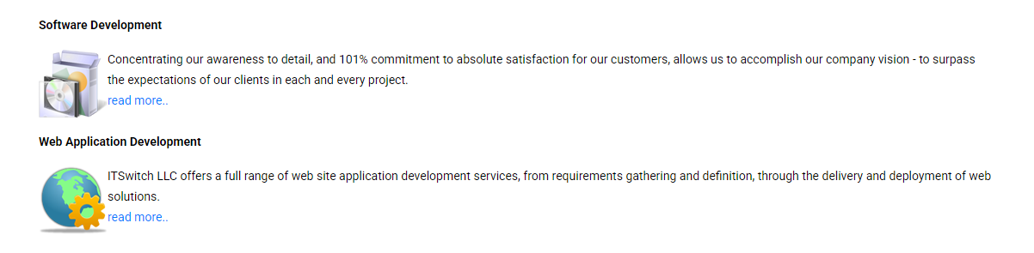

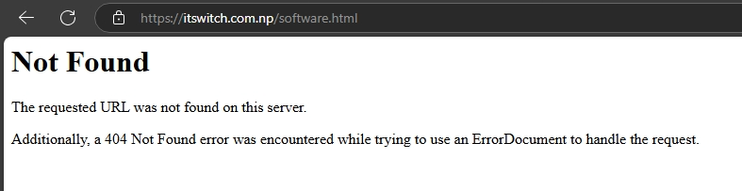

* There is the same problem with the testimonial section as well.



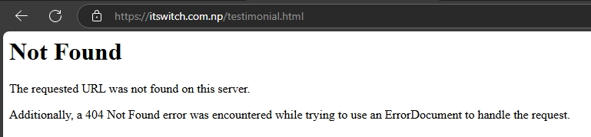

## **Nepal Hygiene and Purity**

* In the FAQ section, we can press the question and it shows that it is pressed but the answer is not shown.

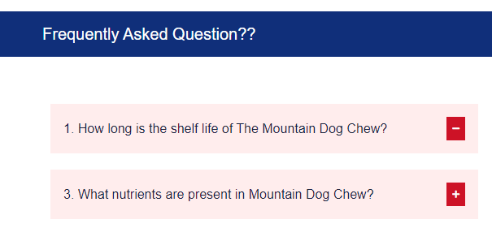

But once we press the “+” button, the answer pops up

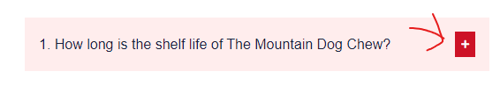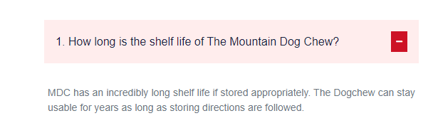

It would be more user friendly if it did the same thing while we press the question as well.

* The “Processing Steps” section displays the information of each step required for Churpi/Chews production which has a small animation when you point your mouse in those boxes but the information is still the same which serves no purpose at all and can be removed as well or some new info can be added instead of the information.

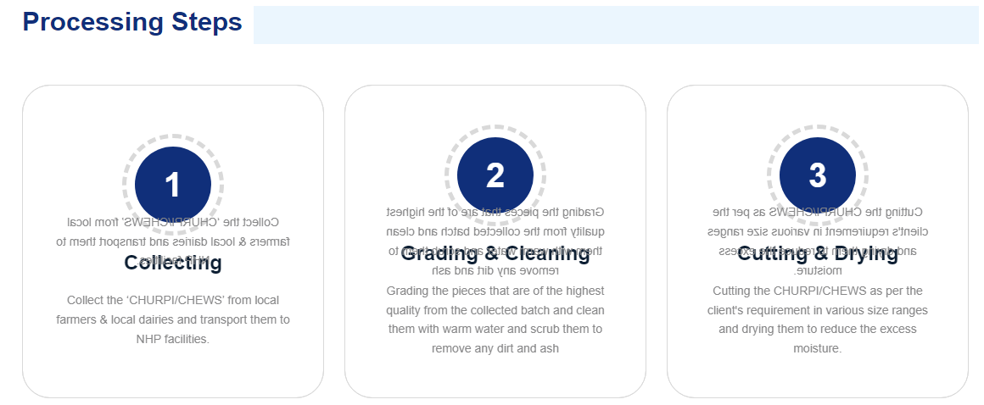

## **Innovative Investment Group**

* The menu bar color contrast is too light from the viewer’s perspective, the bottom half of the menu is a bit difficult to read

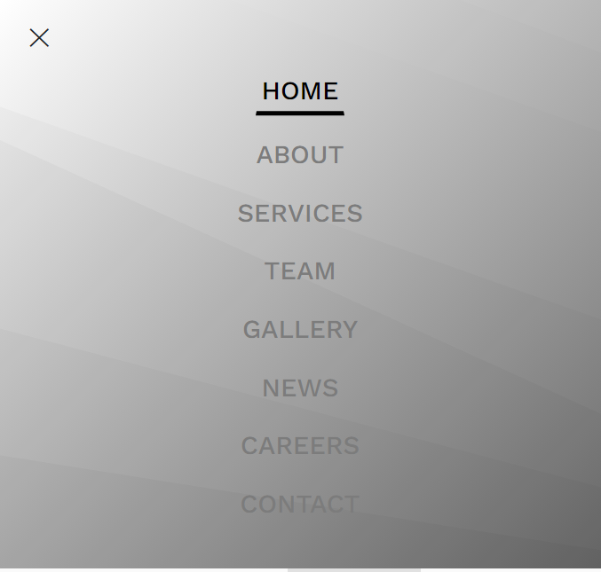

* The news and article section looks very messy, there is too much information on this section. As a user, it is visually confusing and hard to focus on the main information.

